HAP培训-IDEA

Author: 刘能 Neng.Liu
Creation Date: January 13, 2017
Last Updated: February 13, 2017
Document Ref:
Version: 1.0

Title, Subject, Last Updated Date, Reference Number, and Version are marked by a Word Bookmark so that they can be easily reproduced in the header and footer of documents. When you change any of these values, be careful not to accidentally delete the bookmark. You can make bookmarks visible by selecting Tools->Options…View and checking the Bookmarks option in the Show region.

To add additional approval lines, press [Tab] from the last cell in the table above.
You can delete any elements of this cover page that you do not need for your document. For example, Copy Number is only required if this is a controlled document and you need to track each copy that you distribute.
 Copy Number _____

Document Control

Change Record
6
Date | Author | Version | Change Reference
2017/02/13 | Neng.Liu | 1.0 | No Previous Document

Reviewers

Name | Position

Distribution

Copy No. | Name | Location
The copy numbers referenced above should be written into the Copy Number space on the cover of each distributed copy. If the document is not controlled, you can delete this table, the Note To Holders, and the Copy Number label from the cover page.

Note To Holders:
If you receive an electronic copy of this document and print it out, please write your name on the equivalent of the cover page, for document control purposes.
If you receive a hard copy of this document, please write your name on the front cover, for document control purposes.
Contents
Document Control ii
Preface 1
1.下载安装IDEA 2
1.1. 下载 2
1.2. 激活 2
2. IDEA使用及配置 3
2.1. 项目导入 3
2.2. 配置tomcat,并运行 4
3. Open and Closed Issues for this Deliverable 6
Open Issues 6
Closed Issues 6

To update the table of contents, put the cursor anywhere in the table and press [F9]. To change the number of levels displayed, select the menu option Insert->Index and Tables, make sure the Table of Contents tab is active, and change the Number of Levels to a new value.

Preface
本文档主要介绍如何下载,安装IDEA以及如何使用IDEA创建,导入项目

1.下载安装IDEA

下载
前往官网下载http://www.jetbrains.com/idea/

激活
http://idea.iteblog.com/ 在以上网址生成激活码
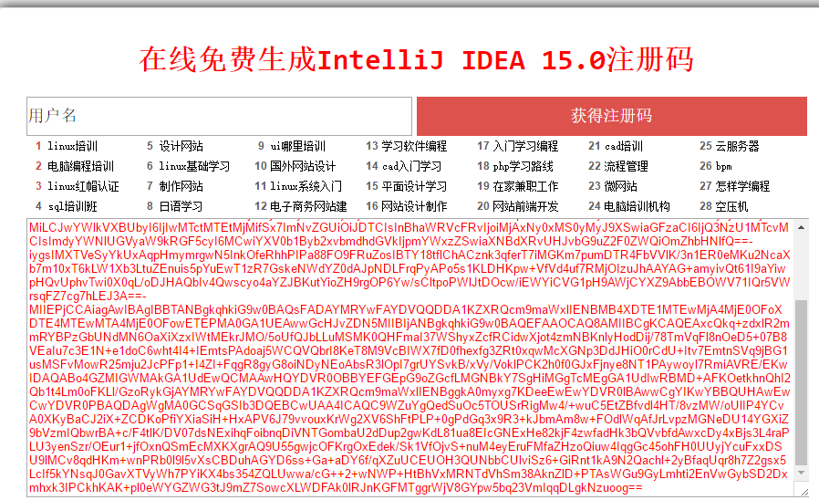
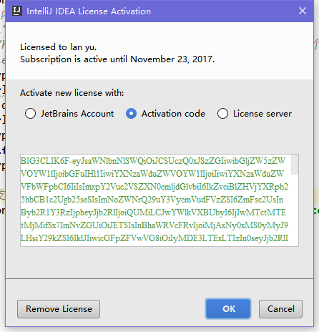
打开Help->Register后,输入生成的激活码即可.

IDEA使用及配置
下面以导入运行HAP项目为例

项目导入
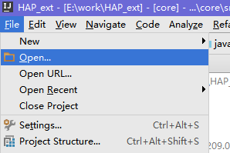
点击File->Open
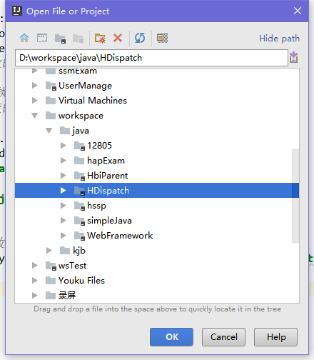
选中项目目录,点击OK
打开项目后,会自动下载maven依赖.依赖下载完成后会看到如下界面
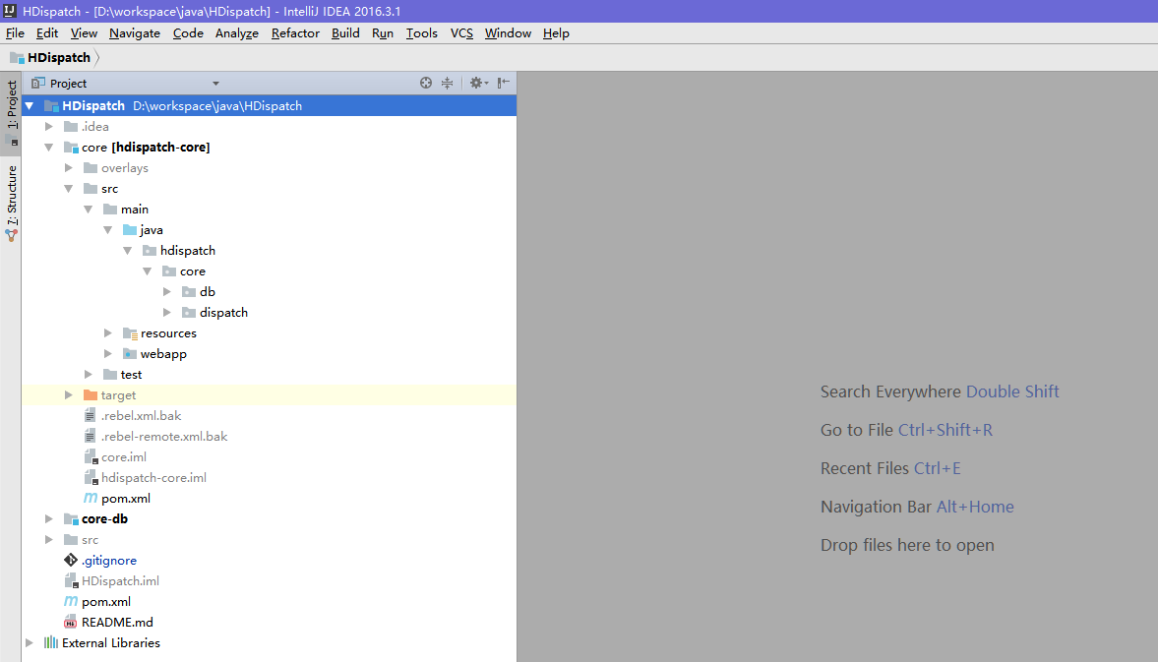

配置tomcat,并运行
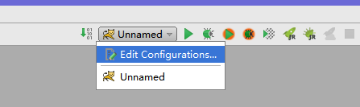
在右上角添加配置
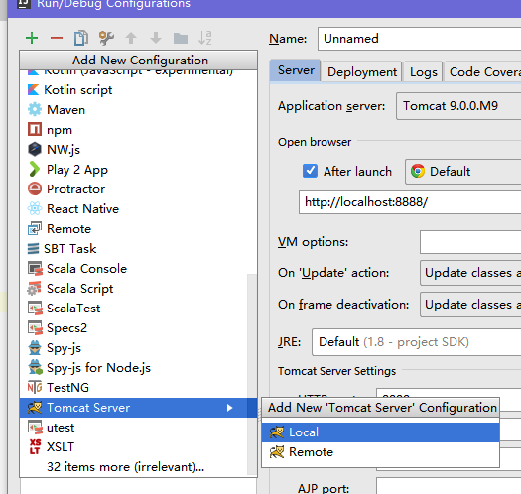
点击+,选择tomcat server->local
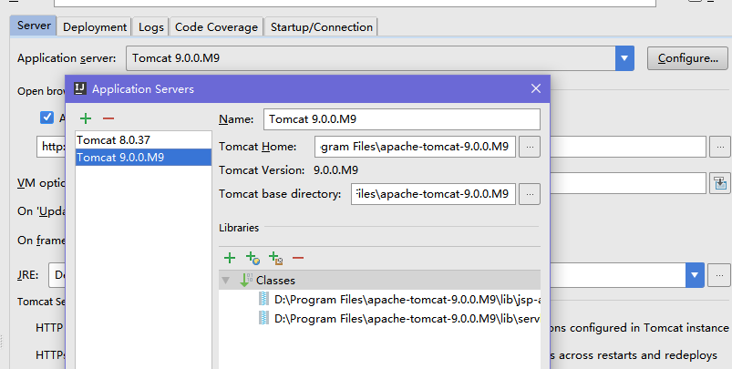
添加上安装好的tomcat
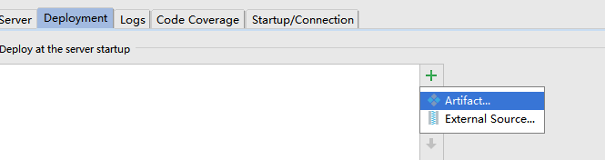
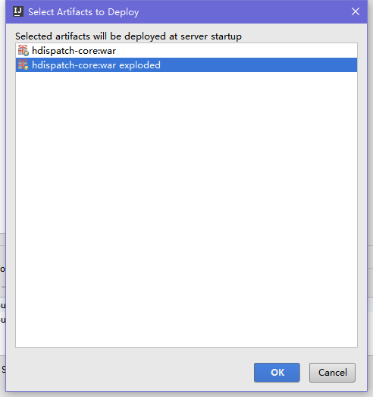
添加好后,即可运行项目

For each field, use the center and right tabs to enter additional information about the field.
Include in the parenthesized list one or more of the following:
Optional
Required
Default
Display Only
List of Values (LOV) source

Open and Closed Issues for this Deliverable
Add open issues that you identify while writing or reviewing this document to the open issues section. As you resolve issues, move them to the closed issues section and keep the issue ID the same. Include an explanation of the resolution.
When this deliverable is complete, any open issues should be transferred to the project- or process-level Risk and Issue Log (PJM.CR.040) and managed using a project level Risk and Issue Form (PJM.CR.040). In addition, the open items should remain in the open issues section of this deliverable, but flagged in the resolution column as being transferred.

Open Issues

ID | Issue | Resolution | Responsibility | Target Date | Impact Date

Closed Issues

ID | Issue | Resolution | Responsibility | Target Date | Impact Date

