HAP培训-Git

Author: 刘能 Neng.Liu
Creation Date: January 13, 2017
Last Updated: February 13, 2017
Document Ref:
Version: 1.0

Title, Subject, Last Updated Date, Reference Number, and Version are marked by a Word Bookmark so that they can be easily reproduced in the header and footer of documents. When you change any of these values, be careful not to accidentally delete the bookmark. You can make bookmarks visible by selecting Tools->Options…View and checking the Bookmarks option in the Show region.

To add additional approval lines, press [Tab] from the last cell in the table above.
You can delete any elements of this cover page that you do not need for your document. For example, Copy Number is only required if this is a controlled document and you need to track each copy that you distribute.
 Copy Number _____

Document Control

Change Record
6
Date | Author | Version | Change Reference
2017/02/13 | Neng.Liu | 1.0 | No Previous Document

Reviewers

Name | Position

Distribution

Copy No. | Name | Location
The copy numbers referenced above should be written into the Copy Number space on the cover of each distributed copy. If the document is not controlled, you can delete this table, the Note To Holders, and the Copy Number label from the cover page.

Note To Holders:
If you receive an electronic copy of this document and print it out, please write your name on the equivalent of the cover page, for document control purposes.
If you receive a hard copy of this document, please write your name on the front cover, for document control purposes.
Contents
Document Control ii
Preface 1
1.Git安装 2
1.1. 下载Git 2
1.2. 安装验证 2
2. Git中常用命令 3
2.1. git init 3
2.2. git status 3
2.3. git add 4
2.4. git commit 4
2.5. git remote 4
2.6. git branch 5
2.7. git checkout 5
2.8. git pull 5
2.9. git push 6
2.10. git stash 6
2.11. git merge 6
2.12. git clone 6
2.13. 更多内容 6
3. Open and Closed Issues for this Deliverable 7
Open Issues 7
Closed Issues 7

To update the table of contents, put the cursor anywhere in the table and press [F9]. To change the number of levels displayed, select the menu option Insert->Index and Tables, make sure the Table of Contents tab is active, and change the Number of Levels to a new value.

Preface
Git是一款免费、开源的分布式版本控制系统，用于敏捷高效地处理任何或小或大的项目。Git的读音为/gɪt/。
Git是一个开源的分布式版本控制系统，可以有效、高速的处理从很小到非常大的项目版本管理。 Git 是 Linus Torvalds 为了帮助管理 Linux 内核开发而开发的一个开放源码的版本控制软件。
Torvalds 开始着手开发 Git 是为了作为一种过渡方案来替代 BitKeeper，后者之前一直是 Linux 内核开发人员在全球使用的主要源代码工具。开放源码社区中的有些人觉得BitKeeper 的许可证并不适合开放源码社区的工作，因此 Torvalds 决定着手研究许可证更为灵活的版本控制系统。尽管最初 Git 的开发是为了辅助 Linux 内核开发的过程，但是我们已经发现在很多其他自由软件项目中也使用了 Git。例如 很多 Freedesktop 的项目迁移到了 Git 上。
本文档主要介绍git的安装,以及常用git命令的使用

1.Git安装

下载Git
从https://git-scm.com/download/win下载安装包并安装.

安装验证
安装好之后再命令行输入git -version,如下表示安装成功.
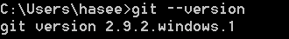

Git中常用命令

git init
git init用于初始化一个本地git仓库.
使用git init -h查看使用帮助
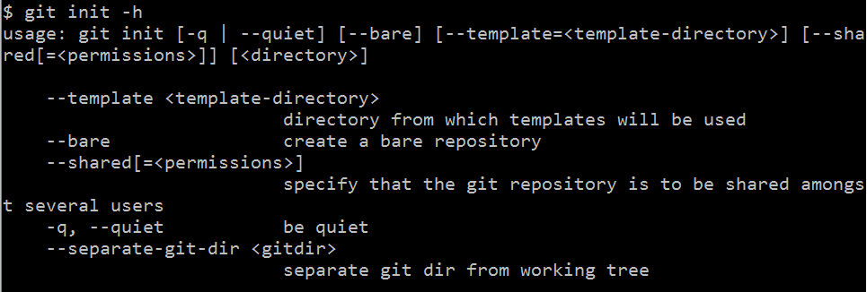
执行git init命令
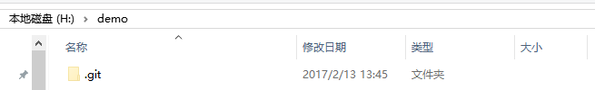
仓库初始化成功后会产生一个.git文件夹

git status
在仓库中新建一个demo.txt文件
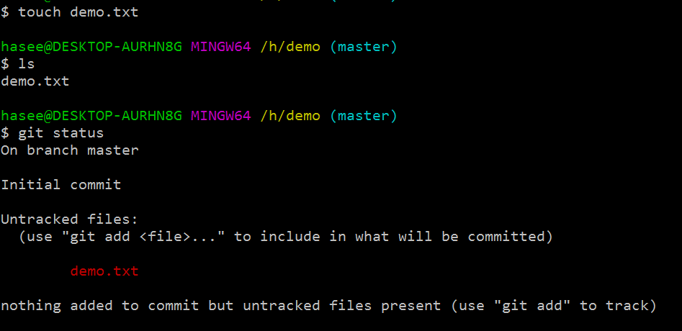
使用git status可以查看到如上的结果.红色表示的是未跟踪的文件

git add
将修改后的文件加入暂存区.
继续上面的操作,执行git add -A, -A说明将全部修改过的文件加入暂存区
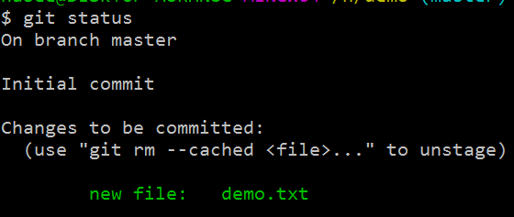

git commit
该命令用于产生一次新的提交.git中的记录都是以commit的形式存在.只要提交记录就会保存在仓库中.
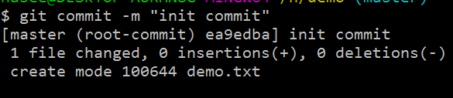
每次提交都会产生一个编号,如ea9edba就是此次提交的编号.提交的时候需要使用-m添加一个commit的描述信息.

git remote
该命令用于查看和添加远程仓库
git remote -v 查看已有远程仓库
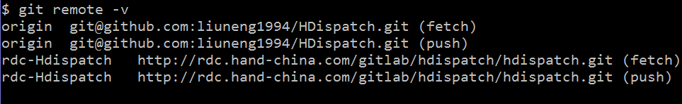
如果已有远程仓库则会看到类似上图的结果.
git remote add <远程仓库名> <远程仓库地址>
使用以上命令可以添加新的仓库

git branch
git branch查看当前仓库所有分支
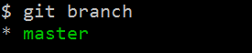
git branch <分支名称>
用于创建新的分支
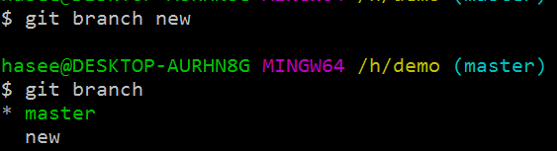
git branch -d <分支名称>
删除指定分支

git checkout
git checkout 用于切换分支
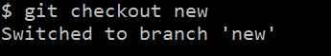
切换分之后,工作空间中的文件也会被替换.
git checkout -b <分支名称>
创建并切换到该分支

git pull
git pull <远程仓库名称> <分支名称>
使用以上命令拉取远程仓库的记录

git push
git push <远程仓库名称> <分支名称>
将本地记录推送至远程仓库

git stash
git stash
将工作空间恢复到最近一次提交,并将暂存区中的修改保存起来.
git stash pop
将上一次stash记录弹出

git merge
git merge <分支名称>
合并其他分支

git clone
git clone <远程仓库地址>
用于克隆远程仓库

更多内容
更多详细的git知识可以查看https://git-scm.com/book/zh/v2/

For each field, use the center and right tabs to enter additional information about the field.
Include in the parenthesized list one or more of the following:
Optional
Required
Default
Display Only
List of Values (LOV) source

Open and Closed Issues for this Deliverable
Add open issues that you identify while writing or reviewing this document to the open issues section. As you resolve issues, move them to the closed issues section and keep the issue ID the same. Include an explanation of the resolution.
When this deliverable is complete, any open issues should be transferred to the project- or process-level Risk and Issue Log (PJM.CR.040) and managed using a project level Risk and Issue Form (PJM.CR.040). In addition, the open items should remain in the open issues section of this deliverable, but flagged in the resolution column as being transferred.

Open Issues

ID | Issue | Resolution | Responsibility | Target Date | Impact Date

Closed Issues

ID | Issue | Resolution | Responsibility | Target Date | Impact Date

